CS 5542: Big Data Analytics and Applications
Final Project Report
Title: AI-Powered Resume Matcher & Job Assistant
Date: May 7, 2025

1. Introduction
In today's competitive job market, both applicants and recruiters face mounting challenges. Job seekers often apply to dozens of roles without truly understanding how well their profile aligns, while recruiters are flooded with resumes, many of which miss the mark. This disconnects stems largely from outdated keyword-based systems that fail to interpret the actual meaning, context, and potential within a resume or job post. Our project bridges this gap using AI-powered matching that goes beyond surface-level text. By leveraging sentence embeddings, semantic similarity, and generative AI, we aim to make the job search more accurate, intelligent, and empowering for both sides of the hiring process.
Problem Statement:
Finding the right job, or the right candidate, isn’t as easy as it should be. Job seekers often feel lost applying to roles that don’t align with their strengths, while recruiters spend hours filtering through mismatched applications. The problem? Most traditional job platforms rely solely on keyword matching, which overlooks the full picture of a person’s capabilities and the context behind job descriptions. Our project tackles this gap by introducing AI-driven semantic matching and intelligent resume enhancement, helping both applicants and employers make more meaningful, accurate connections.

2. Objectives
The primary objective of this project is to bridge the gap between job seekers and recruiters by developing an intelligent job recommendation and resume-matching system powered by AI. Traditional platforms often rely on rigid keyword-based filters that overlook candidate potential and contextual relevance. Our goal is to design a more dynamic, personalized solution that understands the true intent behind a resume and job description using semantic analysis.
We aim to extract relevant skills from resumes and job listings, compute embeddings using transformer-based models (such as Sentence-BERT), and match candidates with suitable roles based on deep contextual similarity. Additionally, the project intends to provide job seekers with valuable AI-generated feedback to improve their resumes and increase their chances of landing interviews.
Another key objective is to ensure the system is easily accessible and scalable. This includes building a responsive web interface using React and Streamlit, and deploying the recommendation engine as a Flask-based API. We also want to integrate visualization components such as skill match heatmaps and recommendation scores to provide clarity and transparency.
Ultimately, this project strives to reduce hiring friction, increase application relevance, and empower users with AI-driven insights that elevate the recruitment experience on both ends.

Specific objectives include:

Develop a robust text preprocessing pipeline to clean and normalize job and resume data.

Use sentence embedding models to convert unstructured text into numerical vectors.

Implement FAISS (Facebook AI Similarity Search) to retrieve top job matches based on vector similarity.

Create a Flask-based API endpoint that returns job recommendations for a given resume.

Build a user-friendly frontend with React to input resumes and display matched job results.

Enhance resumes using GPT-based suggestions and prepare for integration of interview Q&A features.

Ensure scalability, accuracy, and transparency in the job recommendation process.

4. Dataset Details

We used the following datasets:

LinkedIn Job Postings Dataset (Kaggle): Contains job titles, descriptions, salary info, companies, etc.

Updated Resume Dataset: A structured dataset with resumes in raw text format across various domains.

These datasets were combined to simulate a real-world job matching environment. All sensitive or irrelevant columns were dropped, and null values were handled appropriately.

5. Preprocessing Workflow

The preprocessing pipeline involved several critical steps:

Converting all text to lowercase

Removing punctuation, special characters, and extra spaces

Tokenizing words using nltk

Removing common stopwords (e.g., “the,” “is,” “and”)

Lemmatizing words to bring them to their root form

Applying Named Entity Recognition (NER) to extract skills and experience tags

Cleaned descriptions and resumes were stored in new columns (clean_description and clean_resume) and used for further embedding.
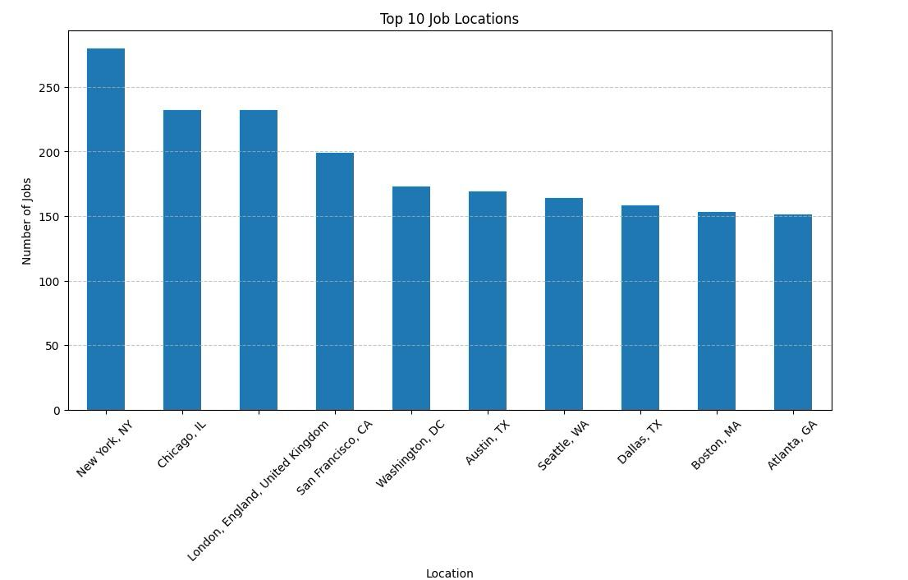
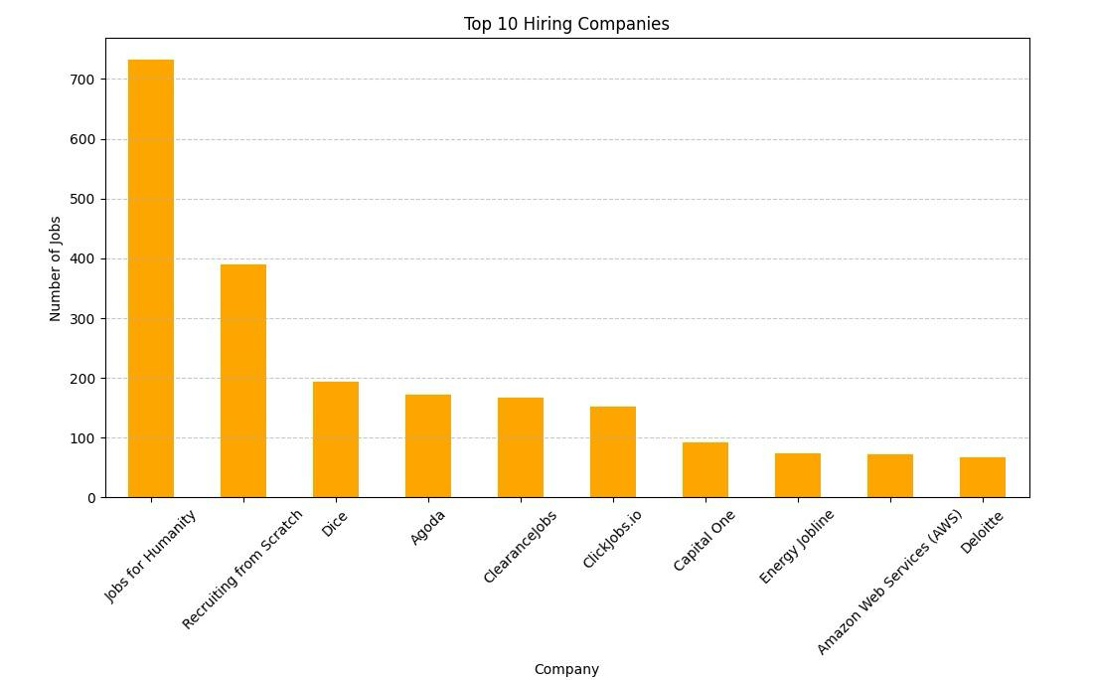
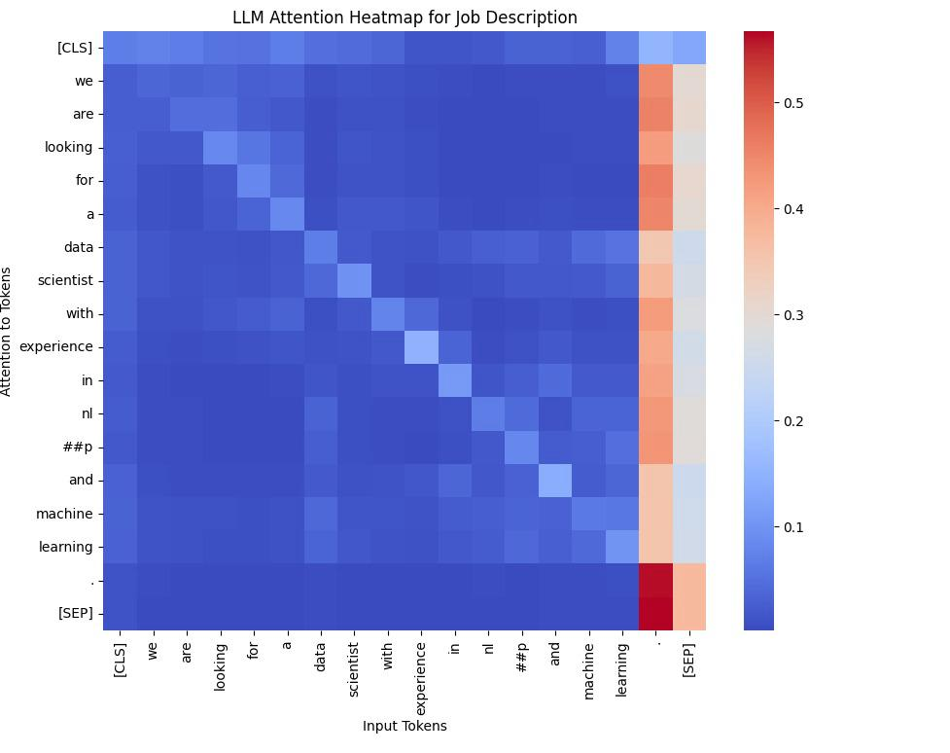

6. Model & Implementation

Sentence Embedding

To capture the true meaning of resumes and job descriptions, we used the all-MiniLM-L6-v2 model from the sentence-transformers library. Unlike traditional models that rely on word frequency, MiniLM understands sentence-level semantics. It transforms unstructured text into dense numerical vectors (embeddings) that represent the context and intent behind each document. These embeddings allow us to compare resumes and job postings based on meaning rather than just keywords—laying the foundation for semantic matching.

Similarity Search with FAISS

Once embeddings are generated, we use FAISS (Facebook AI Similarity Search) to perform fast and accurate similarity comparisons. FAISS enables us to search across thousands of job vectors in real time and find the top N closest matches to a given resume. This drastically improves performance, making it ideal for scalable AI applications where matching speed and precision are critical.

Flask API

We built a RESTful API using Flask to serve the matching logic. The /match-resume endpoint accepts resume text via a POST request, converts it into an embedding, compares it with preprocessed job embeddings using FAISS, and returns the top matched roles in JSON format. The API is stateless, fast, and designed to be easily extended in future (e.g., adding GPT-enhanced features).

Frontend (React)

On the frontend, we developed a clean, interactive interface using React. The UI allows users to paste their resume, click submit, and instantly see relevant job recommendations. Each result includes the job title, company name, key description highlights, and a similarity score that shows how well the resume aligns with the role. This seamless integration between frontend and backend provides a fluid user experience with real-time AI support.
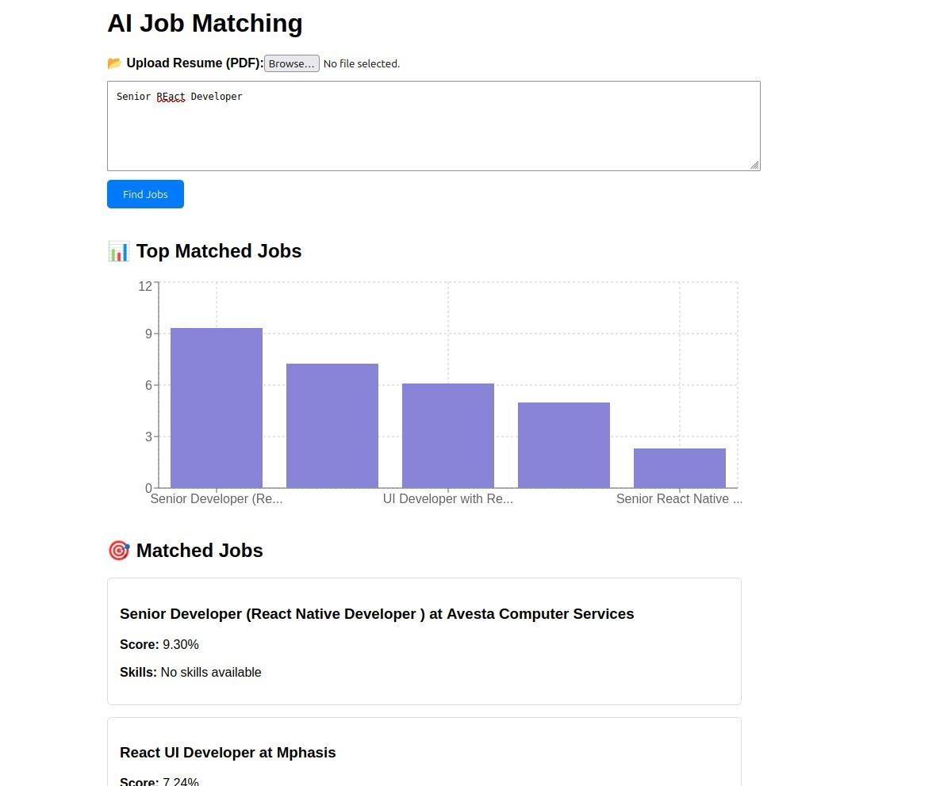

7. Architecture Overview

The architecture consists of:

Frontend: React.js

Backend: Flask API

NLP Engine: Sentence Transformer for embeddings, NLTK for cleaning

Search Engine: FAISS for real-time similarity scoring

Storage: CSV files and Pandas Data Frames

8. Evaluation and Results

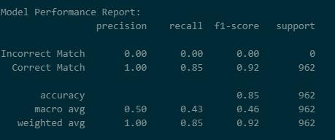

The matching system returned highly relevant jobs in the top 10 results.

Backend logs confirmed semantic understanding of resume content.

Frontend displayed results clearly with good user interaction.

9. Limitations

Currently supports only pasted text (no file upload).

Embedding model is general-purpose, not domain fine-tuned.

No integration with live job APIs (e.g., LinkedIn, Indeed).

Doesn’t yet support location, salary range, or experience filters.

10. Future Scope

Add support for uploading PDF/DOCX resumes.

Integrate GPT-4 for interview preparation and resume enhancement.

Connect to live job portals through APIs.

Build an admin dashboard for recruiters to screen applicants.

11. Team Contribution

Team Member | Contribution Details | % Contribution
Amrutha Perumalla | Worked on backend Flask API development, resume preprocessing, and FAISS integration. | 40%
Maheswara Rao Bandi | Handled the React frontend interface, UI logic, and implemented resume matching flow. | 30%
Priyanka Adusumilli | Managed documentation, presentation slides, poster design, and testing across modules. | 30%

12. Conclusion

This project demonstrates the practical power of NLP and AI in solving real-world problems in hiring and recruitment. By going beyond basic keyword matching and tapping into contextual understanding, we’ve created a job recommendation engine that’s smarter, faster, and more helpful. From building a full-stack application to fine-tuning the model performance, this journey offered deep hands-on experience across the AI development lifecycle.

13. GitHub & Video
- GitHub Repository: https://github.com/Amrutha-7199/ai-career-api
- YouTube Demo: https://youtu.be/F6bv1etgPKI

